
Hon. Balasaheb Thackeray Agribusiness and Rural Transformation (SMART) Project
Full Project Proposal (FPP)
(Template)

Sub Project

Sub-Project Title:……………………………………………………….

Submitted by
...................................................,Community Based Organization (CBO),
Block-……………………….. District-…………………………

Index

Section 1 :- Preliminary information of CBO
Section 2 :- About selected Crops, marketable surplus and its value chain
Section 3 :- About proposed Sub –project
Section 4 :- Sub Project Implementation Plan
Section 5 :- Sub-project Budget and Financial Analysis
Section 6 :- Assumptions
Section 7 :- Social Action Plan
Section 8 :- Environmental Action Plan .
Section 9 :- Procurement Plan

Section 1- Preliminary information of CBO

  - General information
1. | Name of the Community Based Organization (CBO)
2. | Address
3. | Details of the contact person | Name:------------------------------------------------------------------------  Designation in CBO:----------------------------------------------------  Mobile Number: --------------------------------------------------------  Email: -----------------------------------------------------------------

  - About registration of organization
1. | Organization type (please mark (√) on appropriate option) | - Farmer Production Company (FPC)  - Cluster Level Federation (CLF)  - Community Management Resource Center (CMRC)  - Other …………..
2. | Whether the organization is registered? | Yes / No
2.1 | If yes, under which act
2.2 | Year of registration and registration number | Registration year -------------------------------  Registration number ---------------------------
3. | PAN number of the organization
4. | Udyog Aadhar number / Udyam registration No. of the organization
5. | Authorized Capital of organization (Rs. In Lakhs)
6. | Paid up capital of organization (Rs. In Lakhs)

  - Details of Board Members
No. | Name of the BoD | Gender M/F | Social category | Land Holding (Ha) | Designation | Education | PAN No. | Aadhar No. | Contact number (mobile number)
Note: Kindly use short form for presenting social category i.e. SC, ST, NT, OBC and General of each BoD
  - Details of trainings in which BoD members were participated as trainee
No. | Name of the training | Duration (days) | Name of organizing agency | Topics covered | Name of members participated in training

  - Details of shareholders / members of CBOs
Total No. of shareholders | Female | Male | Scheduled Castes | Scheduled Tribes | Marginal  Farmers  (0-1 ha) | Small farmers  (1-2 ha) | Medium farmer  (2-5 ha.) | Big farmers  (More than 5 ha.) | Tenants | landless

  - Details of other participating CBOs if any (If there is more than one promoter agency (CBO), then provide details of other agencies in following table )
No. | Name of agency | Address | Name of contact person | Contact no. | Total number of members / shareholders

  - Details of movable and immovable property owned by the organization
SN | Types of assets | Unit | Total units | Present market value per unit (Rs.) | Total market value (Rs.)
A | Immoveable Assets
1
2
 | Total (A)
B | Moveable asset
1
2
 | Total (B)
 | Gross total (A+B)
Note: provide details of assets owned by organisation such as. Land , building , agri. produce collection centre , cleaning and grading machinery , Processing related machineries, other available machinery and equipment if any, warehouse , cold storage, vehicle , furniture , IT related infrastructure such as computer, printer etc.
  - Details of licenses obtained by CBO (DML, Udyog Aadhar / Udyam registration , shop act and other licenses)
SN | Name of license | Issuing agency/department | License no and date of issuing | Validity (duration)

  - Details of ongoing business activity of CBO along with snapshot on farmers participation (year 20—to --)
Sr.No. | Name of business activity | Number of participated members
Sr.No. | Name of business activity | Members of CBO | Non-member
A | Aggregation and bulk marketing of agri. / Horti commodities
1
2
B | Primary processing on agricultural commodities (cleaning and grading)
1
2
C | Bulk procurement and selling of agricultural inputs (Fertilizer, seeds etc.)
1
2
D | Seed production
1
2
E | Others (e.g. processing, direct marketing, custom hiring center etc.)
1
2

  - Annual turnover of CBO ( last three years)

Details | Year- 20-- to -- | Year- 20-- to -- | Year- 20-- to --
Annual turnover (Rs. Lakh)
Note: -Annual turnover should be given as per the audit report. Definition of turnover is as follows
“Turnover ” means the gross amount of revenue recognized in the profit and loss account from the sale, supply, or distribution of goods or on account of services rendered, or both, by a company during a financial year.)

Section 2 – About selected Crops, marketable surplus and its value chain
  - Details of major crops selected for sub-project and its marketing status (average of last three years)
No. | Crop | CBO members Area under particular crop (Ha.) | Average productivity (tons per Ha.) | Total Production (tons) | Marketable surplus (tons) | Quantity of produce Aggregated and sold by CBO (tons) | Quantity of produce sold by member at individual level (tons)

    - Details of agro produce aggregated and sold by CBO (Average of last three years)

No. | Buyer | Agriculture Commodity ( quantity in MT )
1 | Processor
2 | Exporter
3 | Organized Retail Chain
4 | Direct marketing License (DML) holder
5 | Other ........specify

  - Existing value chain of key crops
A ‘value chain’ in agriculture identifies the set of actors and activities that bring a basic agricultural product from production in the field to final consumption, where at each stage value is added to the product.

    - Value chain of the selected crop (key chain) along with percentage of the marketable surplus is sold? (Please refer annex for knowing how to write value chain.)

    - Challenges in existing value chain of selected crops
1.
2.
3.
    - Potential remedies to address above issues in value chain
1.
2.
3.
  - Whether the CBO has conducted a market survey for mapping potential buyers / market? Yes /No
    - If yes, please provide details
----------------------------------------------------------------------------------------------------------------------------------------------------------------------------------------------------------------------------------------------------------------------------
    - Details of potential buyers/markets identified through survey

No. | Name of buyer/market | Address | Contact person and its No. | E-mail Id | Agri. / Horti. Produce

Section 3: About proposed Sub -project

- Name of the proposed sub project :

- Type of sub project (please mark (√) on appropriate option)

  - Sub project - Productive Partnership (PP)

  - Sub project – Market Access Plans (MAPs)

  - Other…..

- Proposed objectives of the sub project :
1.
2.
3.
- About sub-project location: Sub project location (village, block, district, distance from block and district headquarter, district/state/national highway etc.)

- No. of Villages covered under sub project -
- Details of existing infrastructure available for the proposed sub-project
No. | Particulars | Details
1 | Location of sub-Project | - Village : -----------------------------------------------------  - Grampanchayat :-----------------------------------------  - Block : ------------------------------------------------------  - District: ------------------------------------------------------  - State: ------------------------------------------------------
2 | Latitude and Longitude of the village | Longitude -----------------Latitude--------------------
3 | Total required land for establishing proposed sub project | ----------------------acre
4 | Whether the land owned by organization | Yes / No  if yes; provide following details  Survey no/ Gat No------------------------------------  Longitude -----------------Latitude--------------------
5 | - Is the land is on lease basis ;  If yes; then its details  - Social Category of the land owner  - Whether the land is encroachment free | Yes / No  Survey no/ Gat No------------------------------------  Tenure of agreement -----------year  Date of agreement :………………………………  Longitude -----------------Latitude--------------------  SC/ST/NT/OBC/GEN  Yes/No ( Certificate of non-encroachment to be attach by relevant authority like DIU Head)
 | Proposed land use | Land under cultivation  Fallow land  Industrial use
6 | Details of facilities available at identified site
6.1 | Whether electricity supply is available | Yes / No  If yes; provide following details  Name of connection holder-----------------------------  Type of power connection: Single Phase / Three phase  Capacity: --------------------------------
6.2 | Whether water is required for running proposed sub projects? | Yes / No  Detail of facilities------------------------------  How many months water is available -------- months in a year
6.3 | Status of road connectivity at selected plot | Road connectivity - Yes / No

- Agri. / Horti. Produce aggregation plan of CBO for next five years
No | Name of commodity | Annual Quantity of produce (MT)
No | Name of commodity | 20--to -- |  | 20--to -- |  | 20--to -- |  | 20--to -- |  | 20--to --
No | Name of commodity | Quantity (MT) | % | Quantity (MT) | % | Quantity (MT) | % | Quantity (MT) | % | Quantity (MT) | %
१
२

- Proposed value chain of selected crop/ s (crop wise) (Please refer annex for knowing how to write value chain.)

- Details of buyers selected for developing value chain: -
(Please provide details of the buyer who signed MoU with CBO )
SN | Details | Description
1 | Name of buyer
2 | Address and contact No.
3 | Details of authorized person (name, designation, contact no. and E-mail id )
4 | Type of buyer organization | 1. Processor  2. Exporter  3. Registered buyers / trader  4. Organized Retailers e.g. D- Mart, Reliance  5. Other ----------
5 | Whether the buyer is registered? | Yes / No  If yes, then under which act ---------------------------
6 | Registration Number/ License Number
7 | PAN number
8 | Buyer total annual average requirement of produce (Quantity in MT)
9 | Quantity of produce to be procured by selected buyer – quantity as per MoU (Year 20-- to --)
  crop | Year | Agro produce (ton)
10 | Annual turnover of buyer Rs. lakh (last three years) | 20-- to –
10 | Annual turnover of buyer Rs. lakh (last three years) | 20-- to –
10 | Annual turnover of buyer Rs. lakh (last three years) | 20-- to –

- Quality parameters of agri. / horti. produce to be procured
(Provide details of specific quality parameters as suggested by the buyer. Other terms and condition i.e. transportation, packaging material, availability of crates/ gunny bags etc. )
Sr.No. | Commodity | Quality parameter for procurement of produce | Other terms / Conditions for produce handing over / transaction
1
2
- How you decided price of commodity (Method for fixing of prices of commodities )

- Responsibilities of CBO and the Buyer for developing value chain of crop commodity
Responsibility of CBO | Responsibility of buyer
Note: Provide details in bullet points on quality parameter/ quantity / transportation / payments / technology / produce handing over etc.

- Proposed Business activity/ies
No. | Business/activities | Operational days in a year (Days) | Remark
A | Post-harvest technology /practices
1
2
B | Secondary processing
1
2
C | Quality production
1
2
D | Marketing management
1
2
E | Other
1
2
Note: Fill up the relevant activity under each component.

- What is the uniqueness and innovation in proposed sub-project?

- Key components of sub-project i.e. construction, machinery and other materials required for proposed business / activities
No | Details of proposed business/activities | capacity | Rate /Unit | Total Unit | Total amount (Rs.)
A | Business/Activity No. 1 …………………………….………………………………………………………………………
A1 | Building and Construction
1
2
A2 | Machinery and equipment
1
2
A3 | other
1
2
 | Total (A)
B | Business/Activity No. 1 ………………………………………………………………………………………………………
B1 | Building and Construction
1
2
B2 | Machinery and equipment
1
2
B3 | other
1
 | Total (B)
 | Total (A+B)

- Specify the benefits of working together to CBO its members and buyer
No. | Benefits to CBO | Benefits to buyer | Benefits to members

Section 4 Sub Project Implementation Plan
4.1 Implementation of key activities proposed under sub-project
No. | Particulars of activities | Year 1 |  |  |  | Year 2 |  |  |  | Year 3 (quarter)
No. | Particulars of activities | Q-1 | Q-2 | Q-3 | Q-4 | Q-1 | Q-2 | Q-3 | Q-4 | Q-1 | Q-2 | Q-3 | Q-4
A | Construction of building
1
2
B | Plant and machineries’
1
2
C | Other ……specify
1
2
D | Other
1
2

Section 5 Sub-project Budget and Financial Analysis

  - Sub project budget and means of finance

    - Budget
No. | Proposed component | Unit | Unit rate | Total unit | Total amount (Rs.)
1 | Building and civil work
2 | Machineries and Equipment
3 | Furniture and Fixture
4 | IT Infrastructure
5 | (preliminary and preoperative )
Total

- Means of finance
No | Component | Amount (Rs.) | Contribution (%)
1 | SMART project support ( subsidy )
2 | CBOs own contribution
3 | Bank loan
4 | Other
5 | Total
* If necessary, the applicant can approach to the bank for obtaining loan. (Borrowing loan from a bank is not mandatory under Smart Project)
5.2 Financial Analysis
5.2.1 Project Cost Summary:
Sr. No. | Component | Amount | *Smart Subsidy % | Smart Subsidy Amount (Rs.)
1 | Land |  | 0%
2 | Building & Civil Work |  | 60%
3 | Machineries & Equipment |  | 60%
4 | Furniture & Fixture |  | 60%
5 | IT Infrastructure |  | 60%
6 | Preliminary and Preoperative Expenses |  | 60%
 | Total
*The above subsidy percentage is indicative. It may change based on the decision of State Proposal Approval Committee of Smart Project.
5.2.2 Depreciation Estimates
Sr. | Component |  | Y1 | Y2 | Y3 | Y4 | Y5 | Y6 | Y7
A. | Land | Opening
 | Rate of Depreciation Per Annum | 0%
 |  | Closing
B. | Building & Civil Work | Opening
 | Rate of Depreciation Per Annum | 3.17%
 |  | Closing
C. | Machineries & Equipment’s | Opening
 | Rate of Depreciation Per Annum | 6.33%
 |  | Closing
D. | Furniture & Fixtures | Opening
 | Rate of Depreciation Per Annum | 10.00%
 |  | Closing
E. | IT Infrastructure | Opening
 | Rate of Depreciation Per Annum | 10.00%
 |  | Closing
 |  | Opening Balance
 |  | Total Depreciation
 |  | Balance Asset
*For ease of calculation it is suggested to use SLM (Straight Line Method)
5.2.3 Amortization
 | Opening Amount | Rate of Amortization Per Annum | Amortization Amount | Closing Amount (Opening Amount – Amortization Amount)
Year 1 |  | 20%
Year 2 |  | 20%
Year 3 |  | 20%
Year 4 |  | 20%
Year 5 |  | 20%
Total
*For ease of calculation it is suggested to use SLM (Straight Line Method)
5.2.4 Bank Loan Projection
Loan Amount :
Rate of Interest Per Annum :
Loan Tenure (in Years) :
Moratorium Period (in Years) :
Year | Principal Outstanding | Principal | Interest
0
1
2
3
4
5
6
7
8
9
10

5.2.5 Revenue and Expenses Assumption
Sr. No. | Proposed Facility/ Activity Name | Capacity | Income @ 100% Capacity | Variable Cost @ 100 % Capacity | Fixed Cost @ 100 % Capacity
Note: kindly refer indicative example presented on next page. Kindly use one row for one business activity.
1
2
3
4
Example (indicative) :
Sr. No. | Proposed Facility/ Activity Name | Capacity | Income | Variable Cost | Fixed Cost
1 | Dal Mill | 1 TPH | 200 Days Operational (5 Hours Per Day)  Tur for 120 Days (600 MT Processed  Tur Dal 70% - (420 MT X Rs. 70,000 = Rs. 2,94,00,000)  Other By-products 30% - (180 MT X Rs. 15,000 = Rs. 27,00,000)  Channa for 80 Days (400 MT Processed)  Channa Dal 75% - (300 MT X Rs. 55,000 = Rs. 1,65,00,000)  Other By-products 25% - (100 MT X Rs. 15,000 = Rs. 15,00,000)  Total Income = Rs. 5,01,00,000 | Raw Material – Tur (600 MT X Rs. 45,000 = Rs. 2,70,00,000)  Channa (400 MT X Rs. 35,000 = Rs. Rs. 1,40,00,000)  Labour – (10 Labours X 200 Days X Rs. 300 = Rs. 6,00,000)  Electricity – (100 Units X 200 Days X Rs. 10 = Rs. 2,00,000)  Packaging Material – (INR 300 X 1000 MT = Rs. 3,00,000)  Total Expenses = Rs. 4,21,00,000 | Manager salary - (1 X 12 Months X Rs. 30,000 = Rs. 3,60,000)  Support staff salary – (4 X 12 Months X Rs. 15,000 = Rs. 7,20,000)  Electricity – (100 kVA X 12 Months X Rs. 150 = Rs. 1,80,000)  Lease/ Rent – (Rs. 10,000 X 12 Months = Rs. 1,20,000)  Maintenance – (Rs. 10,000 X 12 Months = Rs. 1,20,000)  Total Expenses = Rs. 15,00,000
2 | Trading (Aggregation Centre, Cleaning & Grading Unit and Marketing) | Cleaning & Grading Unit -1 TPH  Aggregation Centre – 20 MT | 200 Days Operational (5 Hours Per Day)  Wheat for 100 Days (500 MT Processed)  Grade 1 - Wheat 70% - (350 MT X Rs. 20,000 = Rs. 70,00,000)  Grade 2 - Wheat 30% - (150 MT X Rs. 17,000 = Rs. 25,50,000)  Moong for 100 Days (500 MT Processed)  Grade 1 - Moong 75% - (375 MT X Rs. 60,000 = Rs. 2,25,00,000)  Grade 1 - Moong 25% - (125 MT X Rs. 50,000 = Rs. 62,50,000)  Total Income = Rs. 3,83,00,000 | Raw Material – Wheat (500 MT X Rs. 16,000 = Rs. 80,00,000)  Moong (500 MT X Rs. 53,000 = Rs. Rs. 2,65,00,000)  Labour – (8 Labours X 200 Days X Rs. 300 = Rs. 4,80,000)  Electricity – (50 Units X 200 Days X Rs. 10 = Rs. 1,00,000)  Packaging Material – (INR 300 X 1000 MT = Rs. 3,00,000)  Total Expenses = Rs. 3,53,,80,000 | Manager salary - (1 X 12 Months X Rs. 30,000 = Rs. 3,60,000)  Support staff salary – (4 X 12 Months X Rs. 15,000 = Rs. 7,20,000)  Electricity – (50 kVA X 12 Months X Rs. 150 = Rs. 90,000)  Lease/ Rent – (Rs. 5,000 X 12 Months = Rs. 60,000)  Maintenance – (Rs. 5,000 X 12 Months = Rs. 60,000)  Total Expenses = Rs. 12,90,000

5.2.6 Projected Profit & Loss Statement
Particulars | Y1 | Y2 | Y3 | Y4 | Y5 | Y6 | Y7
Capacity Utilization
Income
Facility 1
Facility 2
Facility 3
Fixed Cost
Facility 1
Facility 2
Facility 3
Variable Cost
Facility 1
Facility 2
Facility 3
Earnings Before Interest, Depreciation and Tax (EBIDT)
Depreciation
Interest
Profit Before Tax (PBT)
Income Tax
Profit After Tax (PAT)
Cumulative Profits
5.2.7 Cash Flow Statement Projection
Sr. | Particulars | Y1 | Y2 | Y3 | Y4 | Y5 | Y6 | Y7
Cash Inflow (Rs.)
1 | Revenue
2 | Working Capital loan
3 | Equity/ Share capital
4 | Smart Subsidy
5 | Term Loan
6
 | Sub Total (A)
Cash Outflow (Rs.)
1 | Capital Expenditure
a
b
c
2 | Operational Expenditure
a | Fixed Cost (Excl. Of Interest)
b | Variable Cost
3 | Loan Repayment
a | Working capital loan - interest
b | Working capital loan - instalment
4
5
 | Sub Total (B)
 | Net Cash Flow (A-B)
 | Opening Cash and Bank
 | Cumulative Cash Balance
5.2.8 Balance Sheet Statement Projection
Particulars | Y1 | Y2 | Y3 | Y4 | Y5 | Y6 | Y7
ASSETS
Current Assets
Cash and Bank Balance
Accounts Receivables
Other Current Assets
Total Current Assets
Gross Fixed Assets
Less: Depreciation
Net Fixed Assets
Pre-incubation Cost
TOTAL ASSETS
LIABILITIES & SHAREHOLDERS EQUITY
CURRENT LIABILITIES
Short Term Debt
Accounts Payable & Accrued Expenses
Other Current Liabilities
Total Current Liabilities
Long Term Debt
Differed Tax Liabilities
TOTAL LIABILITIES
Share capital
Smart Grant-in-aid
Reserves and Surplus
Add: Opening Balance (P/L Account)
Profit & Loss) During the Year
Appropriation – Dividend
Total Reserves
TOTAL EQUITY
TOTAL LIABILITIES & EQUITY

5.2.9 Financial Indicators

- Return on Capital Employed (RoCE) or Return on Equity (RoE)
- Net Present Value (NPV)
- Internal Rate of Return (IRR)
- Payback Period (Project/ Equity)
- Break Even Point (BEP)
- Debt Service Coverage Ratio (DSCR)
- Sensitivity Analysis
Key Points for Information
- Return on Capital Employed (RoCE) or Return on Equity (RoE)
RoCE or Return Equity for the project shall be more than 10% to consider the project is financially viable
- Net Present Value (NPV)
With a discount rate of 10% and a span of 7 operational years, the NPV should be positive to consider that the project is financially viable.
- Internal Rate of Return (IRR)
The project internal rate of return shall be more than 10% as per the current financial scenario of the country, If the project IRR is more than 10% then the project is feasible for investment.
- Payback Period (Project/ Equity)
The Pack Back Period (Project/ Equity) shall be less than 5 years to consider that it is financially viable
- Break Even Point (BEP)
The average breakeven percentage shall be more than 50% to consider that it is financially viable
- Debt Service Coverage Ratio (DSCR)
DSCR shall be more than 1.5 for better performing project.
- Sensitivity Analysis
The robustness of the proposal can be been checked through a sensitivity analysis based on unique application of +10% and -10% variations on the costs and quantum assumed for developing the proposal (4 scenarios derived from such analysis shall be represented).
*The above financial viability parameters are indicative and based on the nature of project it may. The final decision to consider the project is viable lies with state level sanction committee

Section 6 : Assumptions

6.1 Key Assumptions
(Applicant should provide basic information for each business activity / facility covered in sub-project. the information will be used for finalizing assumptions and undertaking financial analysis. )
The following information should be filled separately for each business activity / facility covered under the sub-project. E.g. If an CBO has decided to set up ‘dal mill’ and ‘aggregation cleaning, grading and marketing of agro produce’, then details of both the activities / facilities should be provided separately in following table)
- Basic Information of the business/facility
No. | Particulars | details
1. | Business activity/Facility | ------------------------------------------------
2. | Area Required for establishing facility | -------------------------(in Sq. Ft):
3. | Capacity of Facility | --------------------/hr per day
4. | No. of hours, the facility will be operational in a day | --------------------hr per day
5. | Capital investment for machinery and equipment’s (as per quotation) | ----------------------Rs.(in lakh)
6. | Investment on civil and construction compoent (As per estimates): | ----------------------Rs.(in lakh)
I | How many days, the facility will be operational in a year | Annual days---------------

- Details of revenue generated through above facility
No. | Finished product | Unit | Whole price /Rs.-------per unit | Retail price /-Rs……per Unit
1
2

- Expenditure on raw material
No. | commodity | Procurement Price Rs… Per Quintal: | Remark
1
2
3
4

- Expenditure on salary of management staff
No. | Designation: | No. of Staff: | Salary Rs….Per Month: | Remark
1
2

- Expenditure on remuneration of labor
No. | Type of workers | No. | Wages Rs…. / per day | Remark
1 | skilled
2 | Semi skill
3 | Un skilled

- Expenditure on rent/lease of plot / sub-project site
No | Component | Land lease Rent Rs-----per month | Remark
1 | land rent
2 | other

- Expenditure on electricity charges required for facility
No | Cumulative HP for all Machineries and equipment’s | No. of Units Consumption Per Hour: | Per Unit Cost Rs…..per unit | Remark
1 | …..HP | …..PER HR.

- Maintenance cost facilities
No | Component | Detail | Remark
1 | Maintenance of machinery, building, equipment etc, | Rs. ---------------------per month
- Other consumables required for production
No. | Name of Consumables | Unit | Total Unit | Cost Per Unit (Rs) | Remark
1
2
3
E.g. edible oil, salt, sugar etc.
- Expenditure on packaging material
No. | Type of Material | Size of Packaging material | Unit | Total unit | Cost Per Unit (Rs.) | Remark
1

- Expenditure on storage/warehouse for product
No. | Crop Name: | Storage Duration (month) | Storage Cost Per Quintal Per Month: | remark
1

- Other Expenditure
No. | Component | Rs/per month | remark
1

- The above information should be filled separately for each business/activity / facility covered under the sub-project. E.g. If an CBO has decided to set up ‘dal mill’ and ‘aggregation cleaning, grading and marketing of agro produce’, then details of both the activities / facilities should be provided separately in following table
- Please refer necessary quotations, estimates, market survey reports etc. for filling up above information.
- In case of additional information concerned project officer/staff should consult with the applicant during preparation of DPR.

6.2 Other assumptions
1. Year wise participation of CBO member
2. Production assumption of various years
3. Average depreciation – machinery, building, IT infra.
4. Interest rate on long and short term loans
5. Insurance
6. Facilitation charges- bulk marketing
7. Income tax

Section 7

SOCIAL ACTION PLAN

Name of Nodal Person of CBO for implementation and reporting of Social Action Plan :

Particulars | Yes/ No | If Yes, Specify
- Information of Sub-project Implementation Area
Does the subproject area falls under Scheduled V (Tribal) Area?
Does the subproject area have Particularly Vulnerable Tribal Groups {PVTGs}?
Does the subproject falls under Left Wing Extremismarea {LWE}?
Does the subproject districts falls under Aspirational District?
- Compliance with Negative List
Does this Subproject involve compulsory acquisition of private land?
Does this Subproject involve purchase of private land?
Does this Subproject involve physical relocation of people, houses, shops, buildings etc.?
Does this Subproject involve closure of access to common routes, facilities and resources?
Does this Subproject involve activities that adversely impact local livelihoods and businesses?
Does this Subproject cover Indigenous Peoples villages/territories’ (villages with scheduled tribe population and designated Schedule V areas) where free, prior, and informed consultations have not been done?
Does this Subproject cover Indigenous Peoples villages/territories (Villages with scheduled tribe population and Schedule V areas) where evidence for broad community support has not been obtained or is not available?
Does this Subproject involve any activities that could negatively affect the social, cultural and religious beliefs, practices and livelihoods of indigenous peoples (tribal people)?
Does this Subproject involve activities that could adversely affect cultural property, including archaeological and historical sites?
Does this Subproject involve any activities that could potentially use forced labour or child labour and other labour-exploitative practices?
Does this Subproject involve deep excavation works, hazardous chemicals, explosives, submergence, dangerous sites which threaten the health and safety of workers and local communities?
Does the subproject involves any hazardous work for labours during construction work?
Does this Subproject involve any activities that could harm the health, safety and wellbeing of women, girls and children?
- Sub Project Implementation
  - Measures for Social Inclusion
Whether CBO will take measures for the inclusion of vulnerable households, including SC, ST, Women Headed household, tenant farmers, returnee migrants and other vulnerable workers in Subproject activities?
  - Tribal Development Plan (For the Subprojects from Schedule V Area)
Whether free, prior and informed consultations with Tribal community has been conducted?
Whether the consent of Tribal Community for Project Implementation has been obtained?
Whether the access and benefits of project activities/facilities to Tribes will be ensured?
  - Land
Whether own 7/12 extract or registered Lease Agreement for rent/lease of private land for 29 years has been attached?
Whether non encroachment certificate of land has been attached ? (by relevant authority like DIU Head/Grampanchayat/Talathi etc.)
  - Labour mitigation measures during civil & Implementation work
Whether CBO will take measures for safeguarding health and safety facilities for workers (when camps are set up)? (e.g. enough space for living, hygiene facility, drinking water. Separate washroom for male & female, crèche/shed for children, training/awareness on The Sexual Harassment of Women at Workplace (Prevention, Prohibition and Redressal) Act, 2013, mechanism to address sexual violence etc.)
Whether CBO will take measures to address risks related with influx of migrant labour from outside? (e.g. measures to prevent crime, communicable diseases, gender base violence, child labour, accidents, etc.)
Whether CBO will take measures to record and address incidents of gender-based violence and sexual harassment?
  - Measures of Health and Safety
Whether CBO will take measures on Community Health and Safety? (e.g. measures to prevent accident, physical injury, sexual exploitation of community member, etc.)
Whether CBO will take measures on Occupational Health and Workers Safety? (e.g. measures to prevent on site accident, physical injury, sexual exploitation of workers, etc.)
Whether CBO will take Safety measures on COVID-19. (Social distancing, use of Mask, etc.)
Sr.  No. | Particulars | Current Status (Baseline of CBO) | Proposed target in the Sub-project
 | Social Inclusion & Gender Integration targets (%)
A | Total No. of Farmers/Members
B | No. of Small and marginal Beneficiaries (& their %)
C | No. of Women Shareholders (& their %)
D | No. of Women Board of Directors (& their %)
E | No. of Schedule Tribes (& their %)
F | No. of Schedule Caste (& their %)
G | No. of Tenants (& their %)
H | No. of Landless (& their %)
I | No. of Women having land title (7/12) (& their %)
- Social Sub-project Targets :

Section 8
Environmental Action Plan
The Environmental Action Plan (EAP) will provide guidance to the CBOs in minimization/mitigation of potential environmental risks/impacts of the agricultural and animal husbandry value chain development activities of the subproject. The environmental baseline information for providing suggestions to CBOs for bringing out performance improvements in the activities of the subproject are collected as per the below-mentioned table-
Sr No. | Agricultural Practices followed in the Subproject | Unit | Current/Baseline  Condition in the Subproject | Target to be Achieved by the end of the Subproject
- For Agriculture Value chain Development Subprojects
1. | Average use of fertilizer-NPK | Kg/ha.
2. | Area in which recommended dose of fertilizers is used | ha.
3. | Area in which fertilizers used is less than recommended dose | ha.
4. | Area in which fertilizers used is above the recommended dose | ha.
5. | Area in which Integrated Nutrient Management (INM) is practiced | ha.
6. | Average use of Pesticides, Fungicides and Herbicides | L/ha.
7. | Area in which recommended dose of pesticides is used | ha.
8. | Area in which pesticides used is less than recommended dose | ha.
9. | Area in which pesticides used is above the recommended dose | ha.
10. | Area in which Integrated Pest Management (IPM) is practiced | ha.
11. | Area in which crop residues are burnt | ha.
12. | Area in which crop residue is recycled for preparing Compost, Farm Yard Manure (FYM), etc. | ha.
13. | Area under Organic farming | ha.
14. | Area under GLOBAL Good Agricultural Practice (G.A.P.) | ha.
- For Animal Husbandry Value chain Development Subprojects
15. | Feeding practice- Open Grazing/Semi stall Feeding | -
16. | Area in which animal manure is used as fertilizer | Kg/ha.
17. | Animals are Vaccinated/ Non-Vaccinated | -
- Valid PUC Certificate for transportation Vehicle- Available/Not-Available |  | -

Note:
- As per the SMART project’s Environmental and Social Management Framework (ESMF) report recommendations, none of the subproject activities should fall under Negative (non-eligible) list of the project activities given in the point no. 3.9, pg no. 48 of the ESMF report.

- 100 % CBOs of the subproject should be trained in the usage of Integrated Nutrient Management (INM) and Integrated Pest Management (IPM) practices in the SMART project’s Value Chain Development School (VCDS). In the subproject, 50 % of the subproject area in hectares will be required to be brought under IPM and INM by the end of the subproject.
- For requirement of Organic (NPOP- National Programme for Organic Production) and/or GLOBAL Good Agricultural Practice (G.A.P.) group certification, project’s financial support of up to 60 % can be availed by the subproject CBOs. The remaining 40 % of certification cost will be required to be raised by the CBOs themselves.

- All the new machineries to be purchased using project’s resources should be energy efficient, vehicles should be Bharat State VI complaint, tractors should be Bharat Stage (CEV/TREM) IV – V, and hold valid PUC certificate.
Web link of the ESMF Report: https://www.smart-mh.org/cdn//2019/08/190818171526_405e4be8b9d3ce2374fe29ce1561a62b.pdf

Section 9 : Procurement Plan
CBO level Procurement plan with Method & Time Schedule for Works, Goods & Consultancy Services
Ref No. | Contract (Description) | Stage : Planned / Actual / Revised | Estimated Cost (Rs. In. Lakh) |  |  | Procurement Method | Review by PCMU/ PIUs (Prior/ Post) | Expected Bid-Opening Date) | Actual Contract Date  ( format )  (i.e.1-Dec-14) | Actual Contract Amount (Rs.Lakh) | Comments
Ref No. | Contract (Description) | Stage : Planned / Actual / Revised | No of Contracts | Unit Cost | Total Cost
1 | 2 | 3 | 4 | 5 | 6 | 7 | 8 | 9 | 10 | 11 | 12
Works
Goods & Equipment
Consultancy Services
List of documents to be presented along with FPP
- Registration certificate of organization
- List of members/shareholder of the organization (As per the record from the Registrar of Companies office or the certificate of competent authority)
- Audit report
- CBO Bank statement
- KYC of Applicant Firm (PAN and GST Certificate Copy)
- Resolution of board of directors - Approval to DPR
- Land ownership document / land lease agreement
- Propose site map presenting road access and surrounding
- No Objection Certificate of Panchyat for setting up of business activities
- Forward linkages - MoUs with Buyers
- Backward linkages – MoUs for produce aggregation - MoUs with farmers groups/ SHGs/ federations/FPC/other CBOs etc.
- Please attach authorized quotations- machineries & equipment’s /estimate- construction of building / pack house
- Water/ electricity connection (proof)
- Letter of intent from bank/financial institution for financing the project
- License/other
Annexure
Example of how to write Value Chain
- Firstly list out all relevant stakeholders involved in the value chain of selected commodity. These stakeholders are Farmers, Input dealers, Traders, Processors, Exporters, Transporters, Banks etc.
- Divide these stakeholder in three parts as mentioned in the diagram i.e. a) Actors b) Actions c) Supporters
- List out all the actors on the left side of the diagram. List out the actions of the actor in the middle part of the diagram.Connect the actors & respective actions by arrow.
- At the right side of the diagram. List out the names of all supporters eg Banks, Universities, Transporters, Insurance agencies etc.

The example of existing value chain of Cotton is mentioned in below diagram

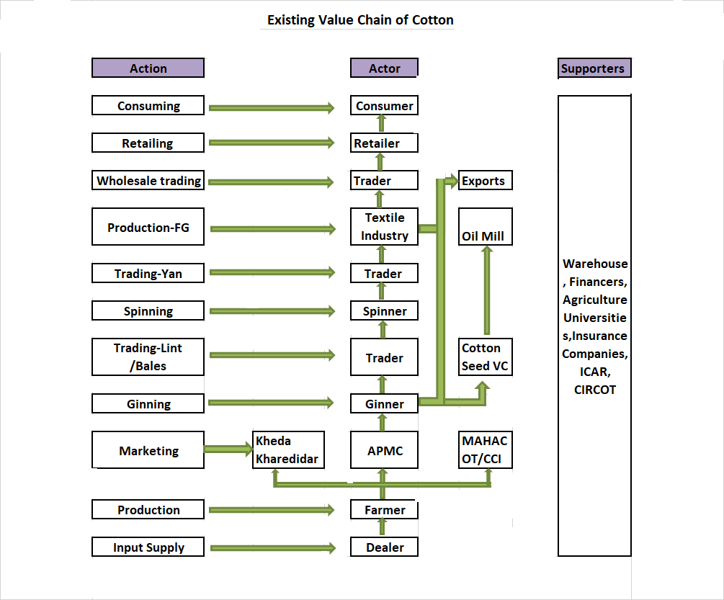

How to present proposed value chain is given below : -
- Study carefully the existing value chain diagram prepared by you. Study the various actions presented in the middle part of the diagram & select the actions which could be done by CBO and gain benefits.
- In the actor side of the diagram put the name of CBO for which action can be done by CBO, then connect the actors & respective actions by arrow.
- Check the list of supporters mentioned at the right side of diagram and add or delete the supporters
- Recheck the presented proposed value chain and finalise it after your insuring all aspects.
The example of proposed value chain of Cotton is mentioned in below diagram
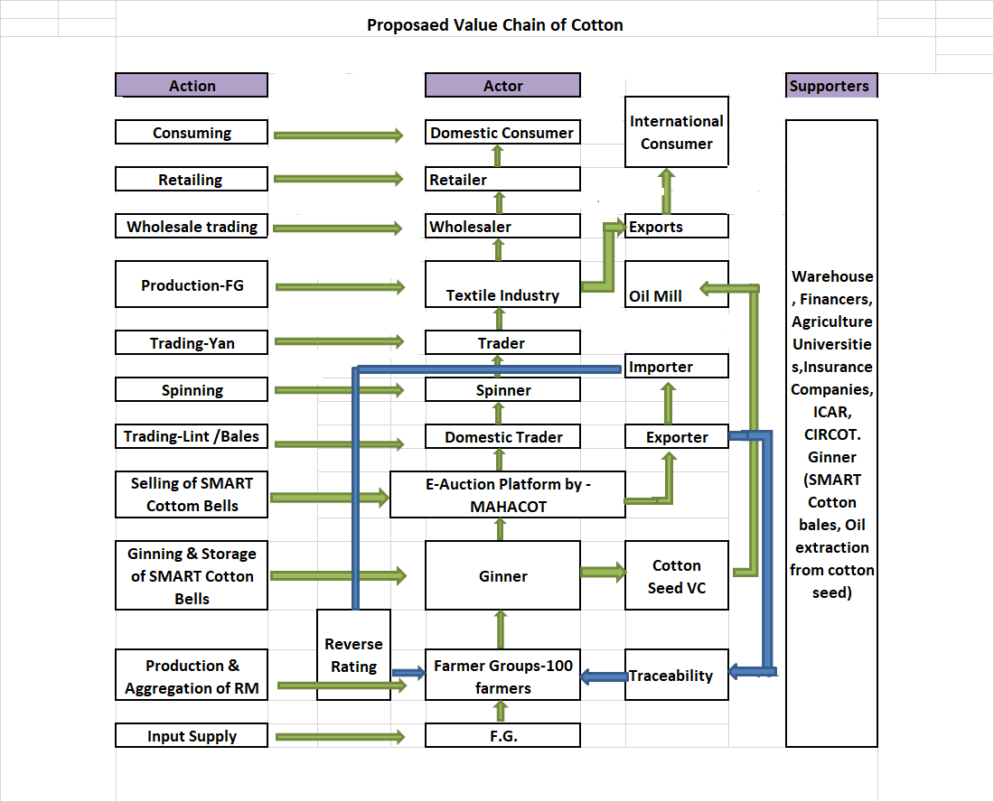

Following the Environment and Social Management Framework of the SMART https://www.smart-mh.org/smart/aboutsmart
List of tribal districts & blocks (Scheduled V Area) is available at https://cdnbbsr.s3waas.gov.in/s3c8758b517083196f05ac29810b924aca/uploads/2019/11/2019112132.pdf
Particularly Vulnerable Tribal Groups - Katkaria (Kathodia), Kolam, Maria Gond
Left Wing Extremism districts Chandrapur, Gadchiroli, Gondia
Aspirational Districts - Nandurbar, Washim, Gadchiroli, Osmanabad
Forced labor means all work or services not voluntarily performed, that is, extracted from individuals under threat of force or penalty
A child under the age of 14 will be considered as child labor. A child over the minimum age of 14 and under the minimum age of 18 may be employed or engaged in connection with the Project only under the following specific conditions: The work is not hazardous in nature and is likely to jeopardize the child's health, safety, or morals. An appropriate risk assessment is conducted prior to work commencing. The Borrower conducts regular monitoring of health, working conditions, hours of work, and the likelihood of potential threat to the child's overall development.
As per the Social Inclusion & Gender Strategy of the Project, out of total beneficiary of the project, 80% will be small & marginal farmers, minimum 30% will be Women beneficiary, minimum 6% will be Schedule Tribes, minimum 7% will be Schedule Caste beneficiary. Also CBO should have minimum 20% Women Board of Directors.

